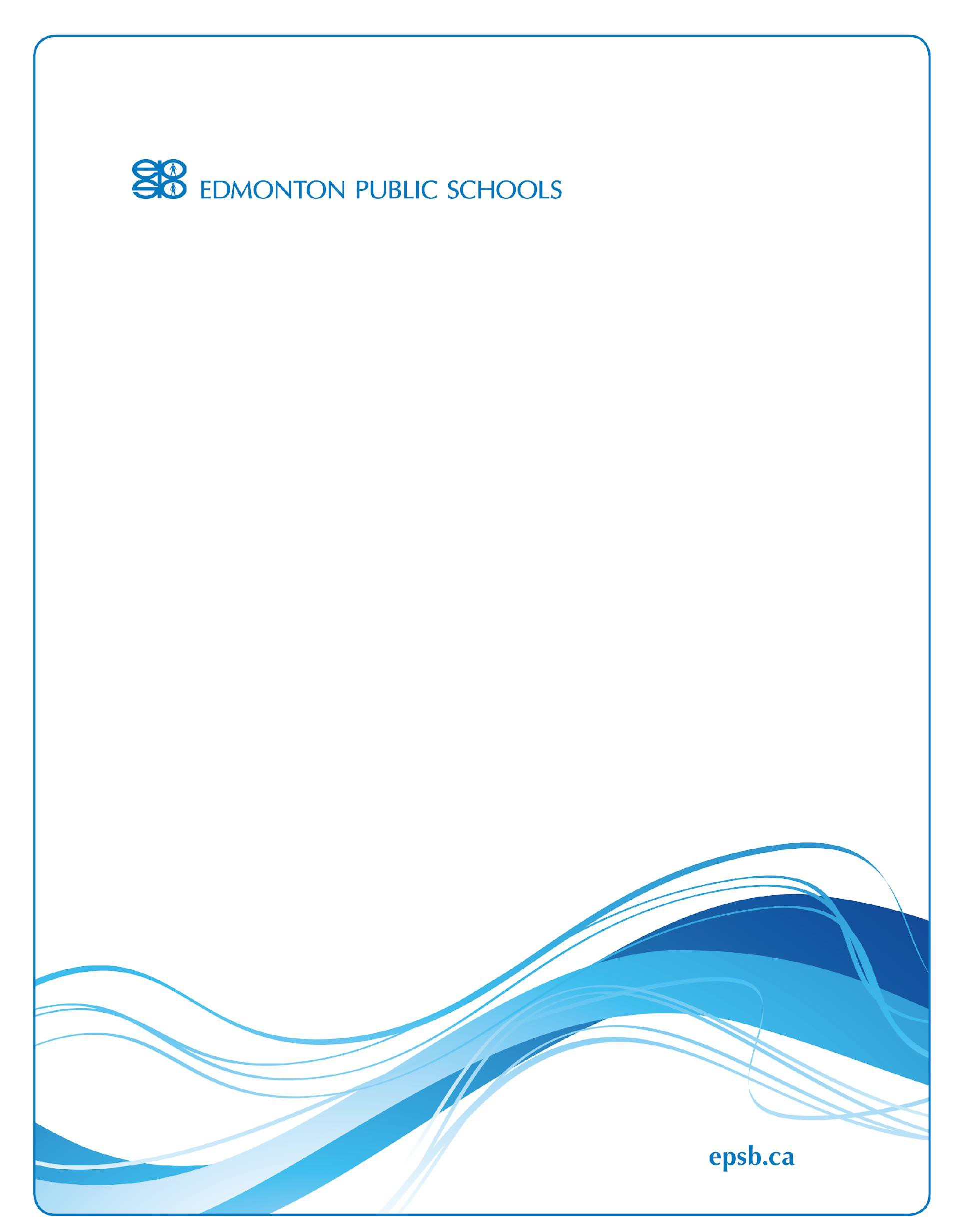

Student Rights and Responsibilities 2023–2024

Vernon Barford School
32 Fairway Drive NW, Edmonton, AB T6J 2C1 Phone: 780-413-2211
Email: vbarford@epsb.ca Website: vernonbarford.epsb.ca

Principal: Lon McMullen Updated: Sept 7, 2023

Our Commitment to High Quality Learning Environments

At Edmonton Public Schools, we are deeply committed to the success and well-being of our students. Each student deserves a welcoming, inclusive, safe and healthy learning environment that supports their learning, respects diversity, and nurtures a sense of belonging.

As a Division, we have established clear behaviour expectations for all students, from Kindergarten to Grade 12. The expectations are outlined in the Board's Student Behaviour and Conduct Policy which was developed in consultation with students, parents, staff and community members. The policy outlines the rights and responsibilities of students and our expectations for student conduct, and the potential responses when students demonstrate unacceptable behaviour.

The role of parents and families in their child's education plays a vital role in promoting positive student behaviour. Partnerships with families continue to make a difference for our students and staff. By working together, we will ensure our students learn the importance of good character and conduct, and our schools will remain safe and secure places to learn and thrive.
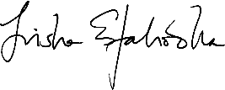

Trisha Estabrooks Board Chair

Student Success and Safety—Our Highest Priorities

It is our shared responsibility to ensure that each student can learn and realize their potential within a safe and caring learning environment. In addition to teaching the necessary learning outcomes, our schools are places where students can develop the character and skills needed to become responsible, respectful, compassionate and successful citizens.

School staff use the Education Act, S.A. 2012, c.E-03, Board Policy HG.BP—Student Behaviour and Conduct and Administrative Regulation HG.AR – Student Behaviour and Conduct as the basis for creating this Student Rights and Responsibilities document. This document is designed to communicate expectations, and balances the overarching rights and responsibilities that are communicated in our policy with the unique context of each school. The expectations and processes outlined in this document are implemented by principals in collaboration with school staff, parents and local communities.

Ensuring each student can thrive in a safe, productive and welcoming learning environment is essential to our work in improving student achievement and high school completion rates. By working together to promote positive attitudes and responsible, respectful behaviour in our schools, we believe students will receive the greatest benefit during their educational journey.
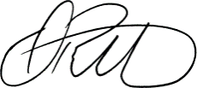

Darrel Robertson Superintendent of Schools

Supporting Student Success
Members of the Edmonton Public Schools community, including students, parents, staff and trustees, have a shared responsibility to help students be successful in school. Safety and well-being is fundamental to our students thriving as learners, and experiencing success and fulfillment both at school and in their lives. This Student Rights and Responsibilities document has been created to communicate clear expectations for how our students are expected to behave in order to ensure they become the best students and citizens they can be.

Parents support their child's success and positive behaviour by:

- taking an active role in their child's personal and academic success
- reviewing expectations outlined in this document with their child and helping them develop the skills required to meet the school's expectations
- helping them to attend school regularly and punctually
- encouraging and modelling collaborative, positive and respectful relationships with others in the school community
- contributing to a welcoming, caring, respectful, and safe learning environment
- reporting to the school any circumstances which may impact student safety

Students are responsible for their behaviour and effort, and are expected to:

- contribute a welcoming, caring, inclusive, respectful and safe learning environment that commits to anti-racism and equity
- learn, practice and demonstrate positive personal and interpersonal skills and attributes
- use their abilities and talents to gain maximum learning benefit from their school experience
- attend school regularly and punctually
- be accountable for behaviour which impacts others in the school, whether or not the behaviour occurs within the school building or during the school day or by electronic means

School staff will help your child succeed by:

- providing a welcoming, caring, respectful, inclusive and safe learning environment that respects diversity, commits to anti-racism and equity, and fosters a sense of belonging
- ensuring that students and parents understand the school's expectations for student behaviour
- establishing supports and processes at the school to proactively guide positive student behaviour
- helping students develop and practice the skills and attributes to meet these expectations
- working with students, parents and other school staff to address behaviour concerns, including implementing appropriate responses to address inappropriate student behaviour

To support a shared understanding of the language and intent of this document, refer to the glossary for a definition of terms.

Our Belief and Commitment

At Vernon Barford, we believe:

- Foci = Ensuring Learning and Positive Development of the whole child.
- Mission = We believe that all children can learn, and our moral responsibility is to ensure that they do.
- We desire to provide a welcoming, caring, respectful and safe learning environment that respects diversity and fosters a sense of belonging for all.
- We value a learning environment and educational process that is rigorous, relevant, relational, and focused on constant individual and collective improvement in all areas.
- We work to ensure that our school culture and systems align and support our school foci (see above)
- We strive to have all members of our school community understand and consistently model the habits of being BLUES (Big Hearted, Leaders, United, Engaged, and Successful). These terms are defined as:
  - Big Hearted = Seeing and positively responding to the needs of others
  - Leaders = Working with others to share one's time, talents, and treasures to make things better for others.
  - United = Recognizing, Respecting, and Honoring that everyone is wonderfully unique while simultaneously focusing on the fact that we are all united in being BLUES.
  - Engaged = Being physically and mentally present, positive in words and actions, and positively productive.
  - Successful = Trying one's best and being willing to model a growth mindset in an ongoing way.
- We understand that the habits associated with being BLUES take time to develop. As such, our school community will intentionally provide ongoing opportunities to learn about, understand, practice, reflect on, and be supported toward the desired characteristics and associated attitudes and behaviours.
- In addition to our focus on curriculum and being BLUES, our school will also intentionally teach and reinforce good habits related to academic and social transfer skills:
  - Academic skills (e.g., goal setting and reflection, keeping track of important information in a calendar, note-taking, research skills, maintaining materials and locker organization, Etc.) and
  - Social skills (e.g., Growth mindset, Focus on learning vs simply achievement, Responsible, respectful, and safe use of technology, Enlightenment about personal gifts and talents, Uplifting language, etc.)

Rights and Responsibilities
Our school Division recognizes the following fundamental rights and responsibilities:

All students have the right to be treated with dignity, respect and fairness by other staff and students.

Students, parents, staff and trustees have a shared responsibility to create and support welcoming, caring, respectful, inclusive and safe learning environments.

All members of our school community are expected to respect diversity and not engage in any form of bullying, harassment, threats, intimidation or discrimination on the basis of race, religious beliefs, colour, gender, gender identity, gender expression, physical disability, mental disability, ancestry, place of origin, marital status, source of income, family status or sexual orientation.

Students and parents have a right to be informed about Division and school expectations for student behaviour. To support this right, all schools' Student Rights and Responsibilities documents will be posted on SchoolZone and on school websites.

Anti-Racism and Equity
All members of the Edmonton Public Schools community:
- have the right to learn and work in an environment that-
- is free of discrimination, prejudice, and racism
- recognizes diversity as a strength
- supports each individual to be included and feel represented in their greater school community, and have the responsibility to:
- demonstrate respect for diverse cultural perspectives, traditions, languages, beliefs and values
- learn and work together as a part of the broader school community to end racism and discrimination
- report, not participate in, and not tolerate acts of racism or discrimination.

These rights and responsibilities are communicated in the Alberta Human Rights Act and the Education Act and are reinforced in Division policies and regulations which are publicly available and include AE.BP—Welcoming, Inclusive, Safe and Healthy Learning and Working Environments, HG.BP—Student Behaviour and Conduct, HG.AR—Student Behaviour and Conduct, HFA.AR—Sexual Orientation and Gender Identity and HAAB.BP –
Anti-Racism and Equity.

Student Behaviour Expectations
To ensure that Vernon Barford is a positive learning environment for everyone, all students are expected to comply with expectations set by our school Division and mandated by the Education Act, as well as school rules which are in place for the benefit of all members of our school community. These expectations apply to all students in the school community, including while learning and engaging with others both in-person and online.

Board Policy HG.BP – Student Behaviour and Conduct and Administrative Regulation HG.AR – Student Behaviour and Conduct outline that students are expected to behave in accordance with section 31 of the Education Act which states that, a student, as a partner in education, has the responsibility to:

- attend school regularly and punctually,
- be ready to learn and actively engage in and diligently pursue the student's education,
- ensure the student's conduct contributes to a welcoming, caring, respectful and safe learning, environment that respects diversity and fosters a sense of belonging,
- respect the rights of others in the school,
- refrain from, report and not tolerate bullying or bullying behaviour directed toward others in the school, whether or not it occurs within the school building, during the school day or by electronic means,
- comply with rules of the school and the policies of the Board,
- cooperate fully with everyone authorized by the Board to provide education programs and other services,
- be accountable to the student's teachers and other school staff for the student's conduct, and
- positively contribute to the student's school and community.

Furthermore, students are expected to:
- resolve conflict or seek assistance to resolve conflict in a peaceful, safe, and non-threatening manner that is conducive to learning and growth. Strategies for addressing conflict between students may include counselling, mediation, or forms of restorative practice.
- use school and personal technology appropriately and ethically
- ensure that they conduct themselves with academic integrity and refrain from and report all incidents of academic misconduct including, but not limited to, cheating and plagiarizing.

Regular Attendance – It’s the Law

Regular attendance is strongly linked to student academic success and a student’s sense of belonging at school. The Education Act reminds parents and students that students are expected to attend school and be punctual every day. Students are only considered to be excused from attending school if they must be away due to:
- sickness or other unavoidable cause
- the day being recognized as a religious holiday by the religious denomination that the child belongs to
- suspension or expulsion
- an exemption from compulsory attendance granted by the Board for a defined period of time

Expectations for Student Attire

At Edmonton Public Schools, students are expected to dress in a manner that reflects a welcoming, respectful, inclusive, safe and healthy learning environment. School expectations for student attire take into account a student’s right to fairness, dignity and respect, and will not discriminate against students
based on race, gender, gender identity, gender expression, sexual orientation, ethnicity, religion, cultural observance, socio-economic status, or body type. Some examples of this are durags, turbans, hijabs and burkas.
Student safety and wellbeing are our highest priorities. Students are also expected to refrain from wearing, carrying, or displaying any clothing or accessories which pose a safety hazard. Students are not permitted to wear lanyards around their neck.

Student Responsibilities in Relation to Public Health

The Division’s first priority is always to ensure the health and wellbeing of students and staff. Students are expected to abide by protocols and expectations that are established at the school, Division, or provincial level for K-12 education, in relation to public health.
These expectations will be communicated to students, parents, and staff by the school administration in a timely manner, and may be updated over the course of the school year in relation to a public health concern as advised by Alberta Health Services.

Vernon Barford Additional Behavior Expectations:

At Vernon Barford, everyone in our school community has the right to learn and work in an environment that is respectful, safe, healthy and focused on ensuring the learning and positive development of the whole child. To preserve these rights:

Students need to be aware of and honour their responsibilities in modelling BLUES behaviour by ensuring their behaviour aligns with the Vernon Barford rights and responsibilities document and the student code of conduct guidelines which are provided, reviewed, and signed by students and parents at the start of each school year (see below).

Parents and Community Members need to be aware of and honour their responsibilities in modelling BLUES behaviour and ensure their behaviour aligns with the EPSB respectful working environments guidelines, EPSB volunteer guidelines, and other documentation that guides adult communication and conduct within the school environment.

Faculty need to be aware of and honour their individual responsibilities in modelling BLUES behavior as well as ensuring their behaviour aligns with the appropriate professional codes of conduct, OHS guidelines, and other EPSB and school guidelines that guide adult communication and conduct.

VERNON BARFORD STUDENT CODE OF CONDUCT:

General responsibilities and expectations

In alignment with the goal of all members of the Vernon Barford school community consistently modelling the habits of being BLUES it is expected that all Vernon Barford students will take responsibility for their behaviour and, with continued support and guidance from the community, school, and family will:

- strive to consistently model the habits of being BLUES
- attend, be punctual and arrive prepared for all classes
- recognize and respect the rights of all students to learn and teachers to teach
- respect the authority of all adults affiliated with the school
- treat each other with courtesy and respect at all times
- behave at all times with dignity, responsibility and appropriateness

- strive for excellence in all academic and personal endeavours
- maintain academic integrity, submitting only their work, acknowledge sources of other's ideas and continue to be ethical when completing assessments and exams
- keep hallways clear and quiet during class time and after school
- not smoke on school grounds, nor have tobacco, e-cigarettes, vaporizers, etc.
- not have or be under the influence of alcohol, drugs, or any illegal substance
- dress appropriately for school
- not have any weapon, weapon replicas, or dangerous goods
- not use tools (scissors) or school supplies, including laser pointers, as weapons to harm, intimidate or threaten others
- not use or have visible electronic devices during class time, in classrooms or the office unless directed to do so by the classroom teacher. At all times, students are asked and expected to use technology in a safe, responsible, and respectful manner.
- not bring or encourage friends to visit Vernon Barford School nor will our students visit or attend other schools without an official appointment. Students will inform teachers/principal(s) of trespassers at Vernon Barford School
- behave positively to and from school, including their time on a bus
- leave valuables at home or secure them appropriately while at school (locked in an assigned locker)

Responsible and Ethical Use of Technology
Our Division is committed to assisting students to become ethical, informed digital citizens. We strive to ensure that appropriate and responsible technology use supports high quality teaching and learning, while also ensuring a respectful, inclusive, and safe learning and working environment.

Technology refers to any computer, software, network, or internet access on any electronic device, including those owned by the student or the Division. Division technology is intended for educational purposes and cannot be used for purposes that are illegal, unethical, disrespectful, hateful, inappropriate, or that cause harm.

Students are accountable for their behaviour when using technology, including when a student's online behaviour outside of the school building or beyond the school day impacts others in the school community. A range of responses as outlined in HG.BP – Student Behaviour and Conduct and HG.AR – Student Behaviour and Conduct, including loss of technology privileges, may be put in place to address unacceptable use of technology.

As digital citizens, students have the following responsibilities:

- Demonstrate respect and integrity
  - understand that expectations for conduct and academic integrity while online, including when using personal devices and outside of school hours, are consistent with school and Division expectations (for example, students should only join online classes in which they are enrolled)
  - use good judgment and participate appropriately in online environments such as meetings, chats, and other applications, and when posting or sharing digital content
  - communicate in a manner that is appropriate, respectful and inclusive at all times

Be safe and secure
  - protect passwords and personal information of self and others including photos, name, age, address and other contact information
  - students must ensure they log in only to their assigned EPSB account, and log off devices and meetings when finished
  - obtain permission before downloading files, including games, music, and movies
  - report, and refrain from searching, viewing, downloading, or sharing, any illegal or inappropriate content
  - do not record or share any audio or video of in-person or online classrooms or other learning activities
  - obtain consent before photographing, recording, or sharing a photo or recording of another person

Respect and protect property
  - demonstrate proper care and security of personal and Division technology
  - understand that students are responsible for the care and security of personal devices brought to school

Electronic Devices:

Vernon Barford School's network, technology, and Internet connection provide learners with access to the world and its vast wealth of resources. School and personal computers and devices are to be used appropriately and ideally for educational purposes while at school. Students shall demonstrate the highest level of respect for the school's technology resources and only use these resources in ways that are appropriate and consistent with the educational goals of Vernon Barford School and Edmonton Public Schools. All students will be issued a unique identification number to log into the computers. Students must keep this number private.

All students are expected to comply with the requirements outlined in this agreement and to demonstrate responsible and appropriate behaviour at all times. By being a student at Vernon Barford, students agree to comply with the terms and conditions outlined. We also realize that good habits related to technology need to be intentionally taught, promoted, and reinforced. For this reason, the safe and effective use of technology continues to be a transfer skill that is formally taught and supported at Vernon Barford.

Unacceptable Behaviour
Any behaviour, whether or not it occurs on school property, or within the school day, which disrupts the educational atmosphere of the school or which interferes with the rights of others to learn, to be respected or to feel safe is unacceptable.

As outlined in Board Policy HG.BP – Student Behaviour and Conduct and Administrative Regulation HG.AR – Student Behaviour and Conduct and supported by the Education Act, unacceptable behaviour includes, but is not limited to:

- behaviours that interfere with the learning of others and/or the school environment
- behaviours that create unsafe conditions
- acts of bullying, harassment, threats, or intimidations whether it be in person, indirectly, or by electronic means
- physical violence
- retribution against any person who has intervened to prevent or report bullying or any other incident or safety concern
- possession, use, or distribution of substances restricted by federal, provincial, municipal, Division or school authorities
- any illegal activity such as:
  - possession, use, or distribution of illegal substances
  - possession of a weapon or use of a weapon (or replica) to threaten, intimidate or harm others
  - possession, use, display, or distribution of offensive messages, videos or images
  - theft or possession of stolen property
- any breach of rules and expectations established by Division administrative regulations or a school- based code of conduct
- failure to comply with Education Act, section 31 regarding student responsibilities

Bullying and Conflict

Bullying is defined in the Education Act as repeated and hostile or demeaning behaviour by an individual in the school community where the behaviour is intended to cause harm, fear or distress to one or more other individuals in the school community, including psychological harm or harm to an individual’s reputation. Bullying also includes the distribution of an intimate image of another person knowing that the person depicted in the image did not consent to the distribution, or being reckless as to whether or not that person consented to the distribution.

Bullying can take different forms:
- physical (e.g., pushing, hitting)
- verbal (e.g., name-calling, threats)
- social (e.g., exclusion, rumours)
- electronic (e.g., using technology to harass or threaten)
Conflict occurs when there is a breakdown in relationships between individuals that results from a disagreement or misunderstanding. While conflicts may require adult intervention, they are considered to be a natural part of how students learn to navigate relationships.

All students are expected to refrain from, report and not tolerate bullying or bullying behaviour directed toward others in the school, whether or not it occurs within the school building, during the school day or by electronic means. Students are also expected to resolve conflict or seek assistance to resolve conflict in a peaceful, safe, and non-threatening manner that is conducive to learning and growth. School staff can help address conflict between students using strategies that may include counselling, mediation, consequences and/or forms of restorative practice.

School Responses to Unacceptable Behaviour
Our Division acknowledges the importance of responsive discipline which involves a continuum of interventions that aim to build a sense of community in schools, facilitate healthy relationships, support behavioural changes, repair harm, and hold students accountable.

Edmonton Public Schools' Board Policy HG.BP – Student Behaviour and Conduct and Administrative Regulation HG.AR – Student Behaviour and Conduct outline the following:

Unacceptable behaviour may be grounds for disciplinary action which provides the student with an opportunity for critical learning and reflection in the areas of personal accountability and responsibility, the development of empathy, as well as communication, conflict resolution, and social skills development.

The specific circumstances of the situation and of the student are taken into account when determining appropriate responses to unacceptable behaviour.
When a student engages in unacceptable behaviour, consequences and responses may include, but are not limited to:

- temporary assignment of a student to an alternate supervised area within the school
- temporary assignment of a student to an alternate learning location
- short term removal of privileges
- interventions such as positive behaviour supports, contracts, counselling, restorative practices
- replacement or reimbursement for loss of, or damage to property
- in-school or out-of-school suspension
- referral to Attendance Board
- recommendation for expulsion

Students are expected to cooperate with investigations by school administration. When contemplating and conducting a reasonable search of student property (including electronic devices), school administration must balance a student's reduced expectation of privacy in relation to school matters, with the need to provide a welcoming, caring, respectful and safe learning environment that respects diversity and fosters a sense of belonging for students and staff.

At Vernon Barford, we are committed to ensuring that our school is a safe and productive learning environment in which learning and positive development of the whole child are possible for all. Where necessary, progressive interventions and/or disciplinary action may be used to address unacceptable behaviour by students.

Additional consequences of violating expectations may include any or all of:

- Having ongoing access to information and learning related to habits associated with being BLUES
- Review of BLUES goals and expectations
- Review of EPSB, school, or classroom guidelines
- Use of proximity, verbal reminder, etc. within the context of the classroom
- Individual conversation with a faculty member(s)

- Adjustment of a routine or process within the classroom environment
- Short-term/ temporary removal from the classroom environment
- Teacher conversation with parent(s) and/or guardians on an as-needed basis
- Referral to the school office
- Opportunity to record and reflect on situations or events that are occurring with an eye toward individual and collective improvement
- Opportunity to access school success coach (when available)
- Conversation with a member of school administration regarding BLUES expectations and/ or EPSB, School, or classroom guidelines
- Opportunity to restore relationships through apology, conversation, etc.
- Positive contributions to school culture or environment through participation in community service
- Temporary removal of privileges (e.g., eating lunch in the office, end-of-day routines, etc.)
- Adjustment of school routines, schedules, etc. temporarily
- Administration parent conference and conversations
- Conference and conversations with EPSB and/or community partners (e.g., social worker, intercultural liaison, EPSB inclusive learning team, etc.)
- Participation in restorative justice processes
- In school suspension
- Out-of-school suspension

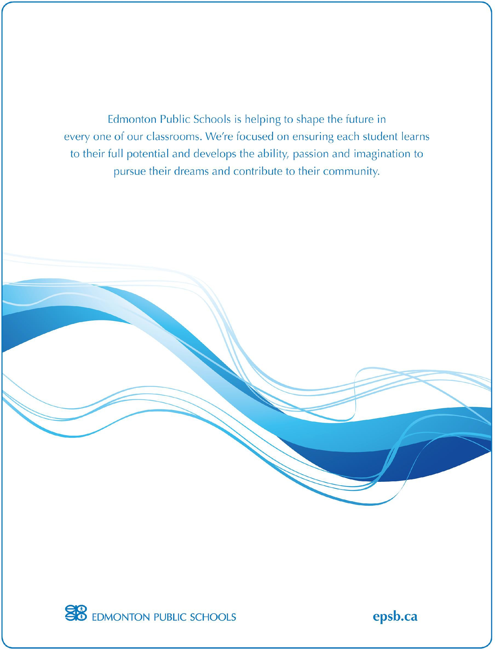
Recommendation for expulsion

Student Rights and Responsibilities 2022-2023 16

Centre for Education One Kingsway NW Edmonton AB T5H 4G9
T 780-429-8000
F 780-429-8318
E info@epsb.ca

