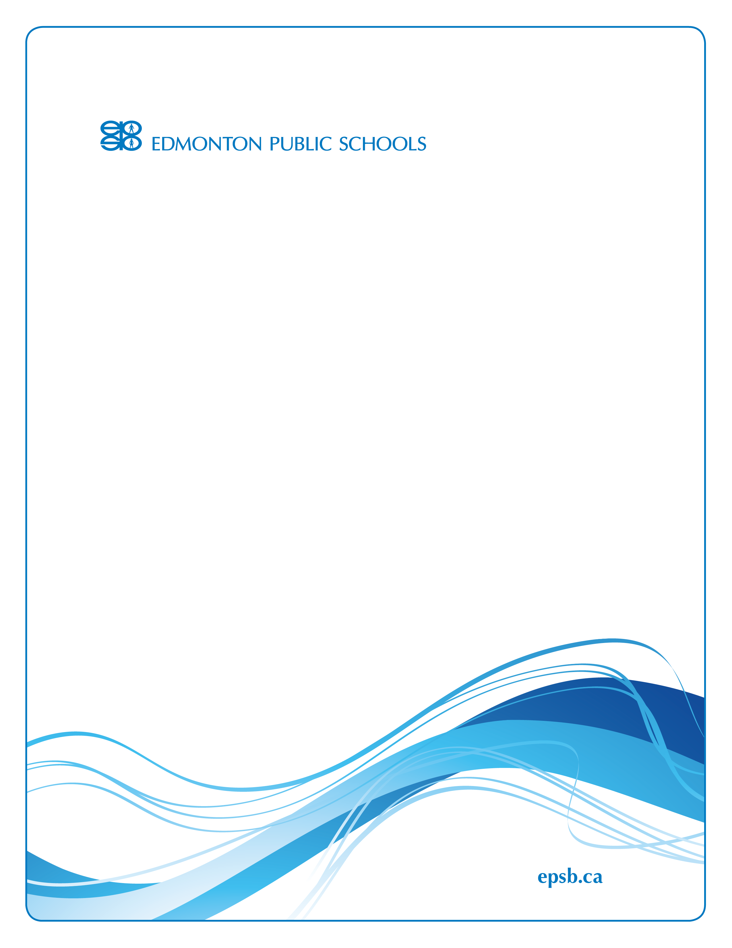

Student Rights and Responsibilities
2023–2024

Bannerman School
14112 23 Street, Edmonton, AB T5Y 2B9
Phone: 780-478-7706
Email:bannerman@epsb.ca
Website: bannerman.epsb.ca
Principal: Tara Copeman
Updated: September 8, 2023

Our Commitment to High Quality Learning Environments
At Edmonton Public Schools, we are deeply committed to the success and well-being of our students. Each student deserves a welcoming, inclusive, safe and healthy learning environment that supports their learning, respects diversity, and nurtures a sense of belonging.
As a Division, we have established clear behaviour expectations for all students, from Kindergarten to Grade 12. The expectations are outlined in the Board’s Student Behaviour and Conduct Policy which was developed in consultation with students, parents, staff and community members. The policy outlines the rights and responsibilities of students and our expectations for student conduct, and the potential responses when students demonstrate unacceptable behaviour.
The role of parents and families in their child’s education plays a vital role in promoting positive student behaviour. Partnerships with families continue to make a difference for our students and staff. By working together, we will ensure our students learn the importance of good character and conduct, and our schools will remain safe and secure places to learn and thrive.
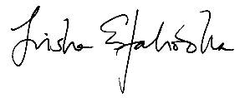
Trisha Estabrooks
Board Chair

Student Success and Safety—Our Highest Priorities
It is our shared responsibility to ensure that each student can learn and realize their potential within a safe and caring learning environment. In addition to teaching the necessary learning outcomes, our schools are places where students can develop the character and skills needed to become responsible, respectful, compassionate and successful citizens.
School staff use the Education Act, S.A. 2012, c.E-03, Board Policy HG.BP—Student Behaviour and Conduct and Administrative Regulation HG.AR – Student Behaviour and Conduct as the basis for creating this Student Rights and Responsibilities document. This document is designed to communicate expectations, and balances the overarching rights and responsibilities that are communicated in our policy with the unique context of each school. The expectations and processes outlined in this document are implemented by principals in collaboration with school staff, parents and local communities.
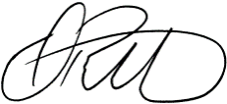
Ensuring each student can thrive in a safe, productive and welcoming learning environment is essential to our work in improving student achievement and high school completion rates. By working together to promote positive attitudes and responsible, respectful behaviour in our schools, we believe students will receive the greatest benefit during their educational journey.

Darrel Robertson
Superintendent of Schools

Supporting Student Success
Members of the Edmonton Public Schools community, including students, parents, staff and trustees, have a shared responsibility to help students be successful in school. Safety and well-being is fundamental to our students thriving as learners, and experiencing success and fulfillment both at school and in their lives. This Student Rights and Responsibilities document has been created to communicate clear expectations for how our students are expected to behave in order to ensure they become the best students and citizens they can be.
Parents support their child’s success and positive behaviour by:
- taking an active role in their child’s personal and academic success
- reviewing expectations outlined in this document with their child and helping them develop the skills required to meet the school’s expectations
- helping them to attend school regularly and punctually
- encouraging and modelling collaborative, positive and respectful relationships with others in the school community
- contributing to a welcoming, caring, respectful, and safe learning environment
- reporting to the school any circumstances which may impact student safety
Students are responsible for their behaviour and effort, and are expected to:
- contribute a welcoming, caring, inclusive, respectful and safe learning environment that commits to anti-racism and equity
- learn, practice and demonstrate positive personal and interpersonal skills and attributes
- use their abilities and talents to gain maximum learning benefit from their school experience
- attend school regularly and punctually
- be accountable for behaviour which impacts others in the school, whether or not the behaviour occurs within the school building or during the school day or by electronic means
School staff will help your child succeed by:
- providing a welcoming, caring, respectful, inclusive and safe learning environment that respects diversity, commits to anti-racism and equity, and fosters a sense of belonging
- ensuring that students and parents understand the school’s expectations for student behaviour
- establishing supports and processes at the school to proactively guide positive student behaviour
- helping students develop and practice the skills and attributes to meet these expectations
- working with students, parents and other school staff to address behaviour concerns, including implementing appropriate responses to address inappropriate student behaviour
To support a shared understanding of the language and intent of this document, refer to the glossary for a definition of terms.

Our Belief and Commitment
At Bannerman School, we believe that when we show respect, take responsibility, and put our best effort into all we do, we can learn together and achieve success! To ensure that high levels of learning can take place, it is important for our school to be welcoming, safe, and caring. Bannerman Bears have the courage to stand up for what is right, and the kindness to take care of others.
Bannerman School is a community of learners centred around student growth and achievement. Our students are provided with a number of learning activities and experiences to allow them to interact with curriculum in meaningful ways. This includes providing access to: educational technology such as Chromebooks and iPads; a wide range of books to engage readers in our school library and classroom libraries; in-school and off-site field trips; math manipulatives to make numbers make sense; and artists in residence programs. As a K to 6 school, our students also support each other in leading and learning by having access to participate in flexible groupings, buddy classes, and volunteer opportunities on a regular basis.
It is critical to equip our students with the essential skills they need to be successful when their school career ends. In order to do this, Bannerman teachers engage in professional learning and collaborate around how to best provide students with what they need to be productive, positive, and prepared citizens. We are committed to helping all students learn at high levels, and sometimes that means students require extra support. Teachers will use a variety of assessments to identify where students need additional time, instruction, and/or assistance, and work together as a team to deliver that support in a timely manner. At Bannerman, we take collective responsibility for every student in the building – ALL of our kids are all of OUR kids!
Our parent community is vital to student success in school. We encourage parents to be active in their child’s learning, and enter into partnership with the school. The Bannerman Parents Educational Club supports student learning by assisting with ensuring universal access for all students to field trips. They also foster community and create fun experiences for kids in school by hosting hot lunches and contributing to school events.

Rights and Responsibilities
Our Division recognizes the following fundamental rights and responsibilities:
All students have the right to be treated with dignity, respect and fairness by other staff and students.
Students, parents, staff and trustees have a shared responsibility to create and support welcoming, caring, respectful, inclusive and safe learning environments.
All members of our school community are expected to respect diversity and not engage in any form of bullying, harassment, threats, intimidation or discrimination on the basis of race, religious beliefs, colour, gender, gender identity, gender expression, physical disability, mental disability, ancestry, place of origin, marital status, source of income, family status or sexual orientation.
Students and parents have a right to be informed about Division and school expectations for student behaviour. To support this right, all schools’ Student Rights and Responsibilities documents will be posted on SchoolZone and on school websites.
Anti-Racism and Equity
All members of the Edmonton Public Schools community:
- have the right to learn and work in an environment that:
  - is free of discrimination, prejudice, and racism
  - recognizes diversity as a strength
  - supports each individual to be included and feel represented in their greater school community, and

- have the responsibility to:
  - demonstrate respect for diverse cultural perspectives, traditions, languages, beliefs and values
  - learn and work together as a part of the broader school community to end racism and discrimination
  - report, not participate in, and not tolerate acts of racism or discrimination.

These rights and responsibilities are communicated in the Alberta Human Rights Act and the Education Act and are reinforced in Division policies and regulations which are publicly available and include AE.BP—Welcoming, Inclusive, Safe and Healthy Learning and Working Environments, HG.BP—Student Behaviour and Conduct, HG.AR—Student Behaviour and Conduct, HFA.AR—Sexual Orientation and Gender Identity and HAAB.BP – Anti-Racism and Equity.

A Bannerman Bear takes care to be kind and respectful. That means all students are expected to:
- Work hard to be on time and ready to learn every day.
- Respect the diversity, personal space, and privacy of others.
- Represent Bannerman School positively by being polite to visitors and people in our community.
- Use appropriate language at all times.
- Be responsible for their belongings and refrain from touching or taking things without permission.
- Dress properly for school and the weather.
- Use technology appropriately and only with the teacher’s permission.
- Be stewards of our school community by putting litter in the garbage, taking care not to damage the trees and plants in our school yard, and using the playground equipment appropriately.
- Keep our school clean by taking off outdoor shoes or boots at the mat by our designated door.
A Bannerman Bear always does their best!

Student Behaviour Expectations

To ensure that Bannerman is a positive learning environment for everyone, all students are expected to comply with expectations set by our school Division and mandated by the Education Act, as well as school rules which are in place for the benefit of all members of our school community. These expectations apply to all students in the school community, including while learning and engaging with others both in-person and online.
Board Policy HG.BP – Student Behaviour and Conduct and Administrative Regulation HG.AR – Student Behaviour and Conduct outline that students are expected to behave in accordance with section 31 of the Education Act which states that, a student, as a partner in education, has the responsibility to:
- attend school regularly and punctually,
- be ready to learn and actively engage in and diligently pursue the student’s education,
- ensure the student’s conduct contributes to a welcoming, caring, respectful and safe learning, environment that respects diversity and fosters a sense of belonging,
- respect the rights of others in the school,
- refrain from, report and not tolerate bullying or bullying behaviour directed toward others in the school, whether or not it occurs within the school building, during the school day or by electronic means,
- comply with rules of the school and the policies of the Board,
- cooperate fully with everyone authorized by the Board to provide education programs and other services,
- be accountable to the student’s teachers and other school staff for the student’s conduct, and
- positively contribute to the student’s school and community.
Furthermore, students are expected to:
- resolve conflict or seek assistance to resolve conflict in a peaceful, safe, and non-threatening manner that is conducive to learning and growth. Strategies for addressing conflict between students may include counselling, mediation, or forms of restorative practice.
- use school and personal technology appropriately and ethically
- ensure that they conduct themselves with academic integrity and refrain from and report all incidents of academic misconduct including, but not limited to, cheating and plagiarizing.
Regular Attendance – It’s the Law
Regular attendance is strongly linked to student academic success and a student’s sense of belonging at school. The Education Act reminds parents and students that students are expected to attend school and be punctual every day. Students are only considered to be excused from attending school if they must be away due to:
- sickness or other unavoidable cause
- the day being recognized as a religious holiday by the religious denomination that the child belongs to
- suspension or expulsion
- an exemption from compulsory attendance granted by the Board for a defined period of time

Bannerman Bears Come to School
We are counting on all students to be at school each and every day to learn and grow! If your child is sick or will be away, please call (780) 478-7706 or email the office at bannerman@epsb.ca so we know they are safe. It is advised to check SchoolZone for upcoming deadlines and assignments, but we will always work with students to get them caught up when they get back.
Our doors get locked after everyone comes in. If class has already started, come to the front door and we will let you in and help them get to class. It is important to check in at the office because after the initial attendance is taken by the teacher, only office staff can override the absence code.
Expectations for Student Attire
At Edmonton Public Schools, students are expected to dress in a manner that reflects a welcoming, respectful, inclusive, safe and healthy learning environment. School expectations for student attire take into account a student’s right to fairness, dignity and respect, and will not discriminate against students based on race, gender, gender identity, gender expression, sexual orientation, ethnicity, religion, cultural observance, socio-economic status, or body type. Some examples of this are durags, turbans, hijabs and burkas.
Student safety and wellbeing are our highest priorities. Students are also expected to refrain from wearing, carrying, or displaying any clothing or accessories which pose a safety hazard. Students are not permitted to wear lanyards around their neck.

What does a Bannerman Bear wear?
- Clothes that are clean and don’t have big rips or tears that make them unsafe.
- Clothes that are comfortable for learning. Underwear must not be visible or exposed; buttocks, genitals, chests, and bellies must be covered.
- Clothes that do not have any: negative language/swears; gory, violent, or sexual images; references to drugs or alcohol.
- Jackets, hats, boots, and mitts outside, but put them away in cubbies or lockers when we are inside. (Some people wear head covers because of their religion, and we recognize and respect that those are not the same as a hat.)
- Hoodies are acceptable, but students are required to keep hoods down in the school so that we can both see who the student is, and so that they can see properly.
- Bannerman Bears always dress for the weather! They bring mittens, hats, winter coats, boots, and snow pants when it is very cold. If your child forgets, the office will phone home to make sure you know and make a plan to ensure they have warm clothes.

Student Responsibilities in Relation to Public Health
The Division’s first priority is always to ensure the health and wellbeing of students and staff. Students are expected to abide by protocols and expectations that are established at the school, Division, or provincial level for K-12 education, in relation to public health.
These expectations will be communicated to students, parents, and staff by the school administration in a timely manner, and may be updated over the course of the school year in relation to a public health concern as advised by Alberta Health Services.

Bannerman Lunch Supervision
Parents who wish their child(ren) to remain at Bannerman School to be supervised over the lunch hour agree to pay a monthly fee. It is not possible for parents to supervise their child’s lunch in the classroom. We ask that if you need to be with your child over lunch that you take them off school grounds.
Children who stay as part of the program must remain at the school for the duration of the lunch hour. Students who need to leave campus for any reason over the lunch hour require written permission from the parent.
Students who stay for lunch must follow several rules to ensure the safety of all students over the lunch hour:
- Students must bring and eat their own lunch. While it is kind to share, it is very difficult to monitor allergies when students share food so we ask that if they have too much/too little, they notify a supervisor and we will help.
- If your child forgets their lunch, the office will phone home. We can provide one if necessary from our emergency lunches and you can send a replacement the next day.
- The child must stay on campus. Students who are part of the lunch program are not permitted to go to friend’s house or the store at lunch.
- Students must clean up after themselves and put all their garbage away and wipe up any spills.
- Students MUST Listen to the lunch Supervisors and treat them with respect. They are adults in our building here to help students be safe over lunch.
It is important to follow the lunch rules to make sure lunch is safe and fun. If rules are not followed, a student may:
- Be assigned community service, such as helping clean the classroom or wiping desks.
- Be moved to another room/supervisor.
- Have to eat lunch in the office.
- Have lunch privileges suspended temporarily or permanently. Parents will have to make arrangements for the child to go home for lunch if he or she cannot eat lunch safely and respectfully at school.

Responsible and Ethical Use of Technology
Our Division is committed to assisting students to become ethical, informed digital citizens. We strive to ensure that appropriate and responsible technology use supports high quality teaching and learning, while also ensuring a respectful, inclusive, and safe learning and working environment.
Technology refers to any computer, software, network, or internet access on any electronic device, including those owned by the student or the Division. Division technology is intended for educational purposes and cannot be used for purposes that are illegal, unethical, disrespectful, hateful, inappropriate, or that cause harm.
Students are accountable for their behaviour when using technology, including when a student’s online behaviour outside of the school building or beyond the school day impacts others in the school community. A range of responses as outlined in HG.BP – Student Behaviour and Conduct and HG.AR – Student Behaviour and Conduct, including loss of technology privileges, may be put in place to address unacceptable use of technology.

As digital citizens, students have the following responsibilities:
- Demonstrate respect and integrity
  - understand that expectations for conduct and academic integrity while online, including when using personal devices and outside of school hours, are consistent with school and Division expectations (for example, students should only join online classes in which they are enrolled)
  - use good judgment and participate appropriately in online environments such as meetings, chats, and other applications, and when posting or sharing digital content
  - communicate in a manner that is appropriate, respectful and inclusive at all times

- Be safe and secure
  - protect passwords and personal information of self and others including photos, name, age, address and other contact information
  - students must ensure they log in only to their assigned EPSB account, and log off devices and meetings when finished
  - obtain permission before downloading files, including games, music, and movies
  - report, and refrain from searching, viewing, downloading, or sharing, any illegal or inappropriate content
  - do not record or share any audio or video of in-person or online classrooms or other learning activities
  - obtain consent before photographing, recording, or sharing a photo or recording of another person

- Respect and protect property
  - demonstrate proper care and security of personal and Division technology
  - understand that students are responsible for the care and security of personal devices brought to school

Bannerman Cell Phone Policy

We understand that many students have phones or devices for safety reasons. At school, however, we want their focus to be on learning, socialization, and participating in physical activity at recesses. To support this, students with cell phones are to either lock their phones in their lockers, or turn their phones in to their teacher and pick them up at the end of the day. This policy extends to fieldtrips as well. This will ensure phones are not at risk to be lost, stolen, or damaged, instruction is not interrupted, and that students are interacting with each other rather than being on a device.
If you require getting a message to your child, please contact the office and we will pass on a message or have them call you. On fieldtrips, a supervisor is required to carry a phone in case of emergency as well as all emergency contact information for the students.
Consequences for inappropriate use of a cell phone may result in:
- the phone being confiscated for the remainder of the day.
- the phone being confiscated and a parent must pick it up from the school.
- the student being required to check their phone in and out through the office.

Unacceptable Behaviour
Any behaviour, whether or not it occurs on school property, or within the school day, which disrupts the educational atmosphere of the school or which interferes with the rights of others to learn, to be respected or to feel safe is unacceptable.
As outlined in Board Policy HG.BP – Student Behaviour and Conduct and Administrative Regulation HG.AR – Student Behaviour and Conduct and supported by the Education Act, unacceptable behaviour includes, but is not limited to:
- behaviours that interfere with the learning of others and/or the school environment
- behaviours that create unsafe conditions
- acts of bullying, harassment, threats, or intimidations whether it be in person, indirectly, or by electronic means
- physical violence
- retribution against any person who has intervened to prevent or report bullying or any other incident or safety concern
- possession, use, or distribution of substances restricted by federal, provincial, municipal, Division or school authorities
- any illegal activity such as:
      - possession, use, or distribution of illegal substances
      - possession of a weapon or use of a weapon (or replica) to threaten, intimidate or harm others
      - possession, use, display, or distribution of offensive messages, videos or images
      - theft or possession of stolen property
- any breach of rules and expectations established by Division administrative regulations or a school-based code of conduct
- failure to comply with Education Act, section 31 regarding student responsibilities
Bullying and Conflict

Bullying is defined in the Education Act as repeated and hostile or demeaning behaviour by an individual in the school community where the behaviour is intended to cause harm, fear or distress to one or more other individuals in the school community, including psychological harm or harm to an individual’s reputation. Bullying also includes the distribution of an intimate image of another person knowing that the person depicted in the image did not consent to the distribution, or being reckless as to whether or not that person consented to the distribution.

Bullying can take different forms:
- physical (e.g., pushing, hitting)
- verbal (e.g., name-calling, threats)
- social (e.g., exclusion, rumours)
- electronic (e.g., using technology to harass or threaten)
Conflict occurs when there is a breakdown in relationships between individuals that results from a disagreement or misunderstanding. While conflicts may require adult intervention, they are considered to be a natural part of how students learn to navigate relationships.
All students are expected to refrain from, report and not tolerate bullying or bullying behaviour directed toward others in the school, whether or not it occurs within the school building, during the school day or by electronic means. Students are also expected to resolve conflict or seek assistance to resolve conflict in a peaceful, safe, and non-threatening manner that is conducive to learning and growth. School staff can help address conflict between students using strategies that may include counselling, mediation, consequences and/or forms of restorative practice.

School Responses to Unacceptable Behaviour
Our Division acknowledges the importance of responsive discipline which involves a continuum of interventions that aim to build a sense of community in schools, facilitate healthy relationships, support behavioural changes, repair harm, and hold students accountable.
Edmonton Public Schools’ Board Policy HG.BP – Student Behaviour and Conduct and Administrative Regulation HG.AR – Student Behaviour and Conduct outline the following:
Unacceptable behaviour may be grounds for disciplinary action which provides the student with an opportunity for critical learning and reflection in the areas of personal accountability and responsibility, the development of empathy, as well as communication, conflict resolution, and social skills development.
The specific circumstances of the situation and of the student are taken into account when determining appropriate responses to unacceptable behaviour.
When a student engages in unacceptable behaviour, consequences and responses may include, but are not limited to:
- temporary assignment of a student to an alternate supervised area within the school
- temporary assignment of a student to an alternate learning location
- short term removal of privileges
- interventions such as positive behaviour supports, contracts, counselling, restorative practices
- replacement or reimbursement for loss of, or damage to property
- in-school or out-of-school suspension
- referral to Attendance Board
- recommendation for expulsion

Students are expected to cooperate with investigations by school administration. When contemplating and conducting a reasonable search of student property (including electronic devices), school administration must balance a student’s reduced expectation of privacy in relation to school matters, with the need to provide a welcoming, caring, respectful and safe learning environment that respects diversity and fosters a sense of belonging for students and staff.
At Bannerman, we are committed to ensuring that our school is a welcoming, caring, respectful and safe learning environment that respects diversity and fosters a sense of belonging for students and staff. Any threat, perceived or real, will be investigated thoroughly. Where necessary, interventions or disciplinary action may be used to address unacceptable behaviour by students.

Bannerman School K to 6 Success Commitment

It is important to follow the rules so everyone is safe and ready to learn. If students need help to follow these rules, Bannerman School staff may:

- Talk to the child about how to behave and help them repair relationships.
- Connect the child with another student, teacher, or trusted adult who can help them express themselves in a positive way.
- Assign increased adult supervision during recess or breaks.
- Remove privileges.
- Have them work in a neighboring classroom or in the office for a short time.
- Take away toys, games, devices, or phones that are distracting or not appropriate to have at school.
- Call parents to come talk to the teacher or principal.
- Have the student complete community service to give back to the school.
- Create an Individual Behaviour Support Plan with the parents, teacher, and principal.
- Have the student work in the office for the day (In-School suspension).
- Have the student work at home with parents (Out-Of-School-Suspension).
- Work with the student and their family to pay back damage to the school, or individual(s).
- Involve other people to help the school problem-solve with parents, like a social worker, police, or Attendance Board.

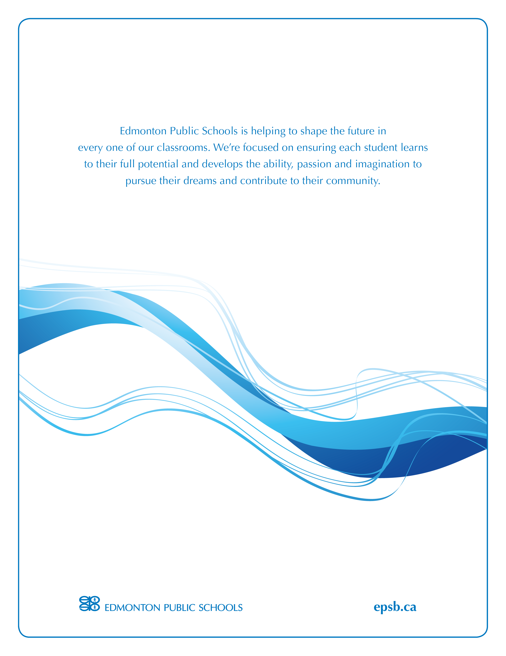

Centre for Education
One Kingsway NW
Edmonton AB T5H 4G9
T 780-429-8000
F 780-429-8318
E info@epsb.ca

